**Assignment 2 – Week 4 (Sub-Queries, View, PL/SQL blocks)**

Submission

***Your submission will be a single text-based SQL file with appropriate header and commenting. Please ensure your file runs when the entire file is executed in SQL Developer.***

Create a new Worksheet in SQL Developer. Save the file as A2_Group#.sql

Your submission needs to be commented and include the question, the solutions, and the output.

Group work acknowledgment

We, ------------(mention your names), declare that the attached assignment is our own work in accordance with the Centennial Academic Policy. No part of this assignment has been copied manually or electronically from any other source (including web sites) **or distributed to other students.**

Specify below what each member has done towards the completion of this work:

Name Task(s)

1-

2-

3-

Tasks

/*

Q1.

Display productId, Name and list Price of those products that belong to category PRODUCE

and that cost less than $100. Sort by Id ascending. Headings should be called ProdId,

Product Name and UPrice.

*/

/* Q 2

Display product Id, Name and list Price of those products that belong to category

starting on C or V and that cost less than $100. Sort by Id ascending.

Headings should be called ProdId, Product Name and LPrice.

*/

/*Q3

Display full name of an employee (like Jones, Larry), job title and hire date,

if they were hired After the last hired Sales Manager. Sort the output by earlier hire dates.

Headings should be called Full Name, Job and Hire Date.

*/

/* Q4

Create a view named as min_price_category. In the view Display Lowest list Price for each category.

Sort the output by the Price descending.

*/

/*Q 5. The Following flowchart determines whether a customer is rated high, mid, or low based on his or her total purchases.

The block needs to determine the rating and then display the results on the screen. The code rates the customer high if total purchases are greater than $200,

mid if greater than $100, and low if $100 or lower. */

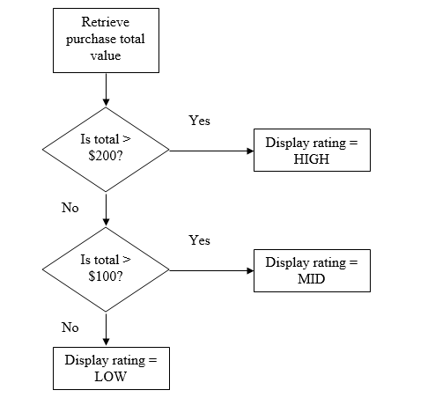

Create a block using an IF statement to perform the actions described in the above flowchart. Use a scalar variable for the total purchase amount and

initialize this variable to different values to test your block.

*/

/* Q 6

Create a block using a CASE statement to perform the actions described in the above flowchart. Use a scalar variable for the total purchase amount and

initialize this variable to different values to test your block.

*/

Grading rubrics

Each question is worth 5pts. Total is 30 pts.

If the output is included without the query, the answer is worth 0.